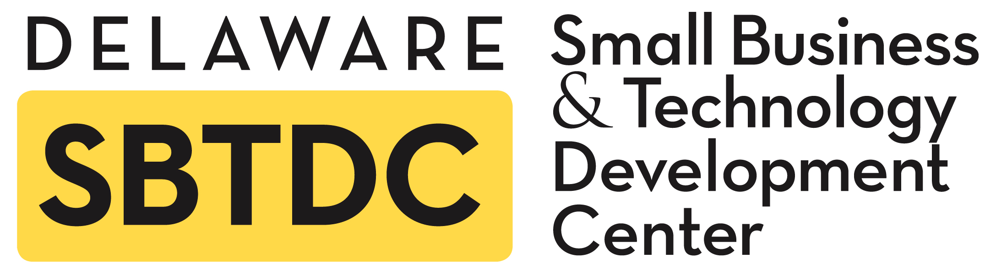

“T” stands for Services to Technology & Innovation-based Businesses

The Delaware SBTDC assists entrepreneurs whose business focus is on innovation, new technology development or new applications of existing technology. Innovation typically involves intellectual property that contributes to a strong competitive advantage in the marketplace. Services include consulting, research and training in the following key areas.

“T” Core Service Components:

1) Business Development Assistance
- Market Potential Analysis (Market Size, Industry, Target Customers, Competitors)
- Assessment of Business Issues (Legal, Transportation, Plant, Equipment etc.)
- Start-up Strategies
- New Product Development Plans

2) Intellectual Property Guidance
- General Intellectual Property Information
- Intellectual Property Strategies and Options
- Referrals to Network of Attorneys

3) Management Team & HR Assistance
- Management Team Assessment
- Identify Gaps, Define Roles & Responsibilities, Referrals to Recruiters.
- Retaining Key Employees, Evaluation and Team Building

4) Access to Capital
- SBIR/STTR Assistance
- Assistance Locating and Preparing for Equity Financing Through Angel and Venture Capital
- Traditional Financing Sources and Preparation

5) Development of Economic Environment
- Networking
- Referral System
- Professional Connections

“T” Core Service Goals:

To Tech-Based Entrepreneurs – To Help Businesses Build a Sound Business Plan, Understand Customers and Markets, Understand the Options Available to Raise Capital, Set Appropriate Goals & Priorities, and Acquire Necessary Skills and Talent.

To The State Of Delaware - To Integrate and Support the Economic Environment for the Long-Term Growth of Delaware’s Technology & Innovation-Based Business Community.

For more information or to request assistance see www.dsbtdc.org

