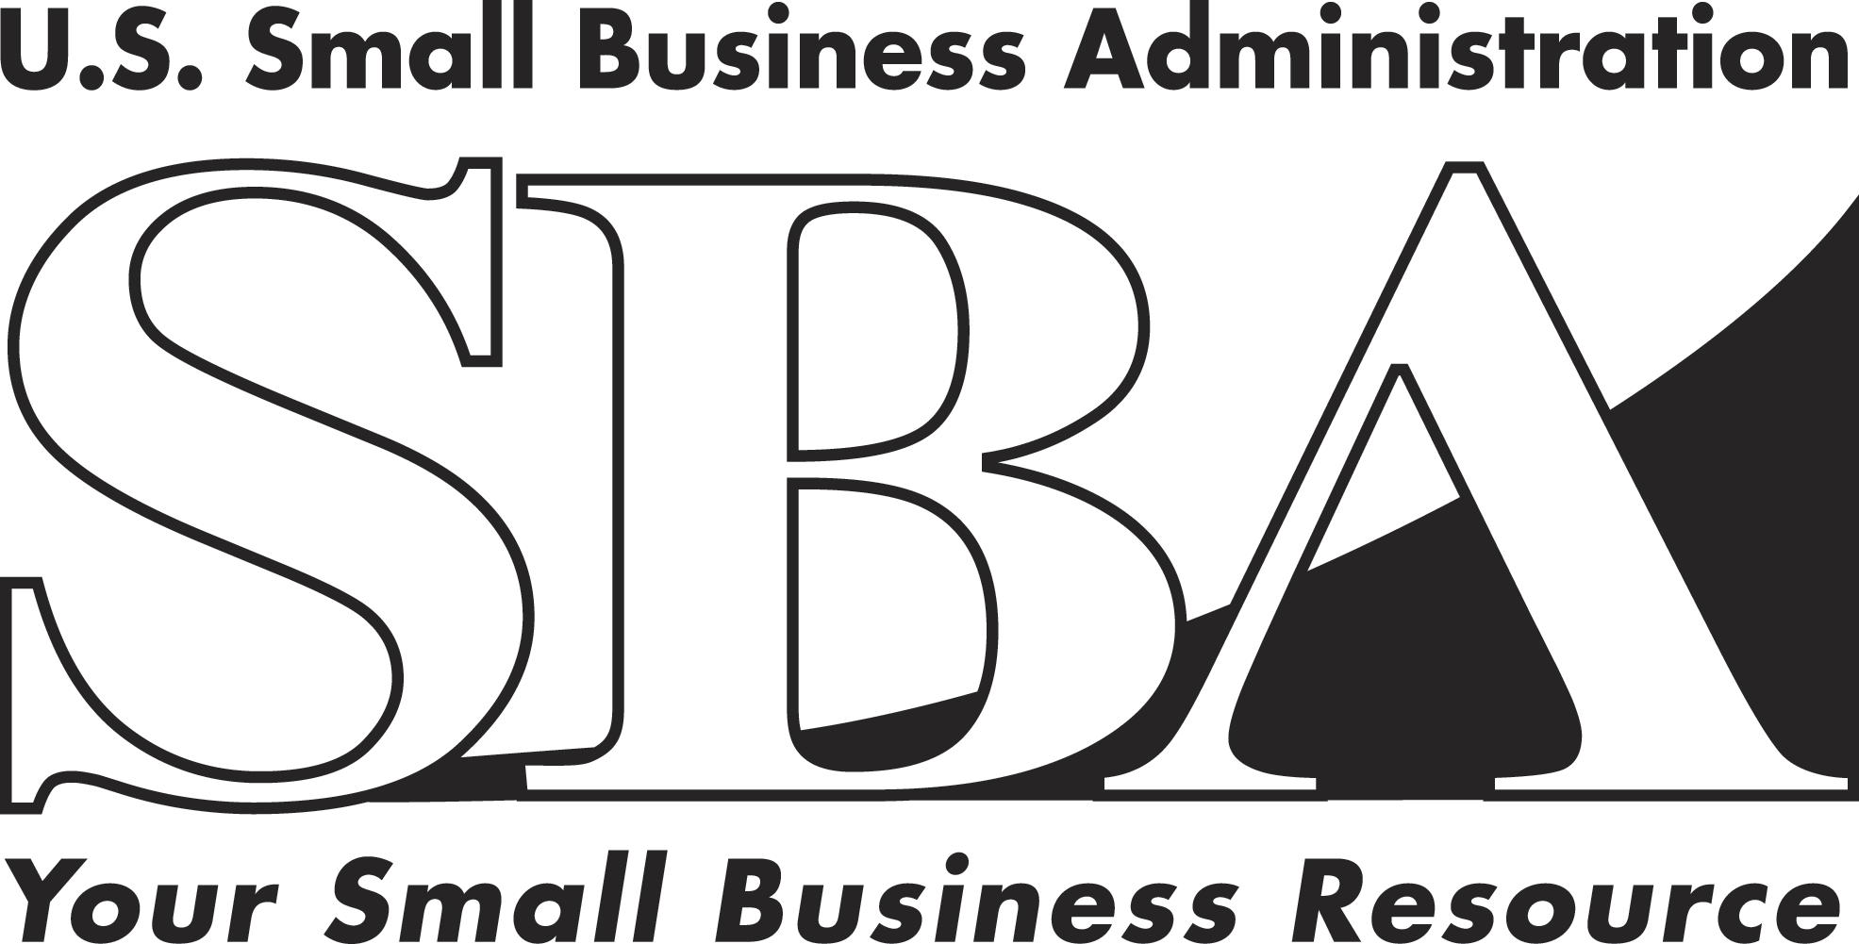 News Release
PRESS OFFICE

Release Date: February 18, 2009 | Contact: Mike Stamler (202) 205-6919
Release Number: 09-10 | Internet Address: http://www.sba.gov/news
SBA Applauds Stimulus Bill, Planning Underway For Broadest, Quickest Small Business Impact
WASHINGTON – The American Recovery and Reinvestment Act contains a package of loan fee reductions, higher guarantees, new SBA programs, secondary market incentives, and enhancements to current SBA programs that will help unlock credit markets and begin economic recovery for the nation’s small business sector.
“The tax incentives and credit stimulus elements of the Recovery Act will truly help small business owners affected by the credit crunch, and will provide financing opportunities to help them create new jobs in their communities,” said Acting SBA Administrator Darryl K. Hairston.

“There’s a lot to digest in the legislation, and SBA has established teams to tackle a wide variety of policy decisions, system modifications, regulatory changes, legal requirements, and new program launches authorized by the President and Congress,” said Hairston.

The bill provides $730 million to SBA and makes changes to the agency’s lending and investment programs so that they can reach more small businesses that need help. The funding includes:
- $375 million for temporary fee reductions or eliminations on SBA loans and increased SBA guaranteed shares, up to 90 percent for certain loans
- $255 million for a new loan program to help small businesses meet existing debt payments
- $30 million for expanding SBA’s Microloan program, enough to finance up to $50 million in new lending and $24 million in technical assistance grants to microlenders
- $20 million for technology systems to streamline SBA’s lending and oversight processes
- $15 million for expanding SBA’s Surety Bond Guarantee program
- $25 million for staffing up to meet demands for new programs
- $10 million for the Office of Inspector General

The bill also authorizes refinancing for certain SBA loans so borrowers can expand their businesses on favorable terms, and expands leverage capability for Small Business Investment Companies.

“We are going to be part of the solution, and this bill gives us specific tools to make it easier and less expensive for small businesses to get loans, give lenders new incentives to make more loans, and help restore healthy SBA secondary markets to boost liquidity,” Hairston said, noting also that more details on implementation will be coming over the next few weeks.

The stimulus bill takes a comprehensive approach and attacks several problems facing small businesses at once by reducing fees, guaranteeing a greater share of certain loans, expanding capacity in the Microloan program, providing new loans to help small businesses keep their doors open through economic hardship, as well as new mechanisms to help unfreeze the secondary markets for SBA-backed loans.

Declines in SBA lending volume last year, which are continuing in FY 2009, reflect problems in the broader credit markets, and present hurdles to small businesses that are seeking credit in the current economy. The financial crisis has created a variety of conditions that impact small businesses, including a lack of liquidity in the banking system, a reluctance of many lenders to extend new loans, tightened credit standards, weaker finances at small businesses, and uncertainty about taking on new debt on the part of many entrepreneurs.

The Recovery Act addresses small businesses’ lending problems, and addresses key investment and contracting issues. The bill helps Small Business Investment Companies better leverage investment capital to reach more small companies. The bill also increases the current contract limit for SBA’s Surety Bond Guarantee program, which will help small businesses compete for contracts.

90 Percent Guarantee
The bill allows SBA to raise its loan guarantee from the current levels to as much as 90 percent for some loans. At present, SBA can guarantee loans up to 85 percent on loans up to $150,000, and up to 75 percent on loans greater than $150,000. The 50 percent guarantee on SBA Express loans would remain unchanged. Increasing the SBA guarantee percentage will encourage lenders to extend more capital to small businesses by increasing the share covered by an SBA guarantee.

Business Stabilization Loans
The bill creates a new SBA loan program to provide deferred-payment loans of up to $35,000 to viable small businesses that need the money to make payments on an existing, qualifying loan for up to six months. These loans will be 100 percent guaranteed by SBA. Repayment would not have to begin until 12 months after the loan is fully disbursed. The bill provides $255 million for this new program. These loans will help ensure that small businesses have time to re-focus their business plans in order to succeed in the long run.

Microloans
The bill expands SBA’s Microloan program, which provides small loans (up to $35,000) paired with technical assistance to start-up, newly established or growing small businesses. The bill provides funding to increase loans from SBA to participating Microlenders by $50 million through September 30, 2010, and adds $24 million in grants to provide technical assistance to borrowers. Historically, these loans reach low-income individuals, women and minorities in both rural and urban areas. Expanding this program through the stimulus bill will help ensure these entrepreneurs are not left behind in the credit crunch.

Refinancing
The bill also gives SBA the power to use the 504 Certified Development Company program to refinance existing loans for fixed assets, providing fresh support for small business expansion. This change will help business owners expand their current development projects and create jobs in their communities.

Secondary Market Expansion
The bill authorizes SBA to establish a secondary market for pools of “first lien” loans under the 504 program. These “first lien” loans from commercial lenders currently have no SBA guarantee. The bill authorizes SBA to deploy federal guarantees for pools of these first lien loans, so that they can be sold to investors in a secondary market. Providing liquidity for these first mortgages will help encourage lenders to continue participating in SBA’s 504 loan program, which provides a key source of capital for community development and other projects.

The bill also empowers SBA to set up a Secondary Market Lending Authority that would make direct loans to broker-dealers that participate in the secondary market for SBA-guaranteed 7(a) loans. These broker-dealers would use the funds to purchase SBA-backed loans from commercial lenders, assemble them into pools and sell them to investors in the secondary loan market. This program may help address some of the issues facing the secondary market for SBA loans and may ultimately help SBA lenders make new loans to borrowers.

Investment Program
The bill helps SBA-licensed Small Business Investment Companies (SBICs) and families of SBIC funds better leverage the capital they use to invest in small businesses. The bill sets maximum levels of funding the agency can provide to these companies at up to three times the private capital raised by those companies, or $150 million, whichever is less. It also raises the percentage any one SBIC can invest in a single small business to 10 percent of total capital, and raises from 20 percent to 25 percent the percentage of any licensee’s dollar investments that must be made in “smaller” businesses.

Surety Bonds
The bill also raises the maximum contract amount that can be covered by an SBA guaranteed surety bond from $2 million to $5 million, and, under certain circumstances, for contracts amounting to $10 million, and provides additional funds to cover the costs of expanding this program. Small businesses need surety bonds in order to bid on and obtain many federal and other contracts. SBA guarantees surety bonds to small businesses that private surety companies would not otherwise be able to extend.

# # #

