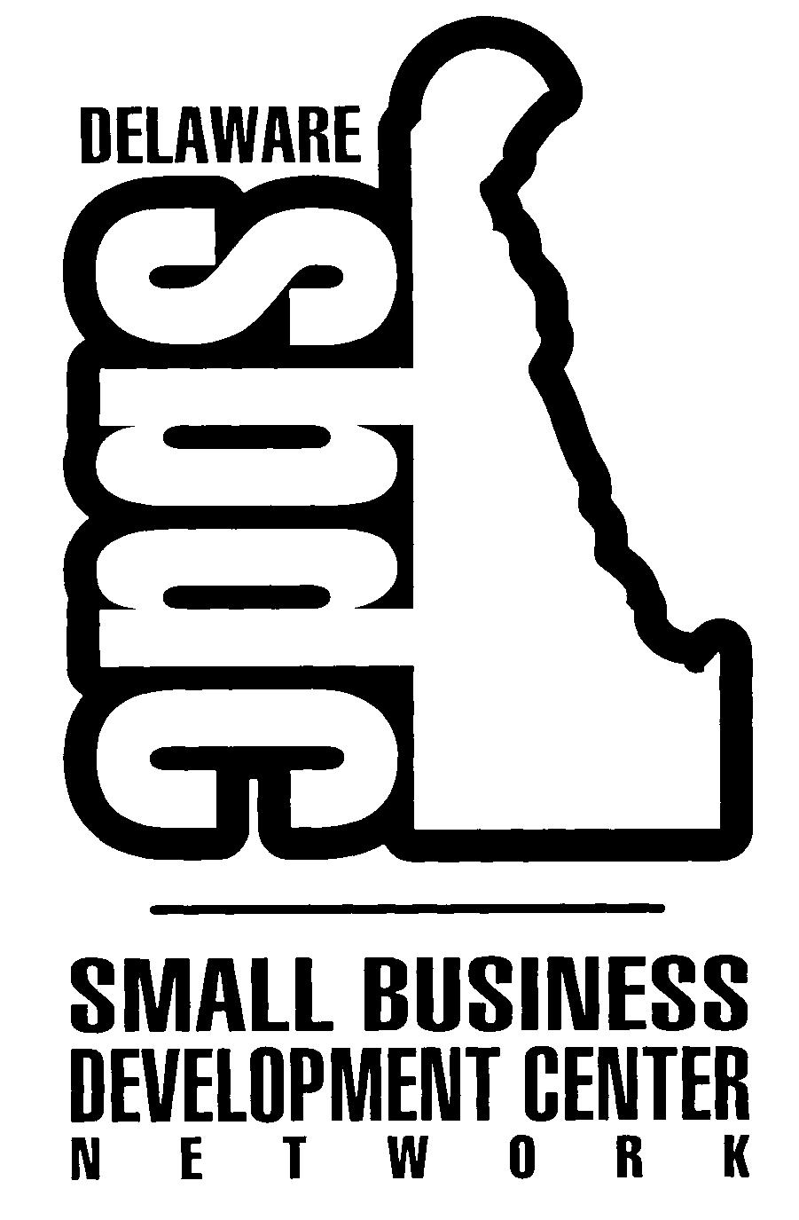
BUSINESS DEVELOPMENT QUESTIONNAIRE

Date: _____

Name: Phone:

Email address: Fax:

In order that the Delaware Small Business Development Center (DSBDC) may provide the best and most efficient service possible, please complete this questionnaire as best as you can. Please return the completed questionnaire to the nearest DSBDC office. A list of our offices can be found on the last page. After the questionnaire has been reviewed, you will be contacted to discuss your proposed business venture. If in the course of our discussion we determine that we are unable to address your specific needs, we will facilitate referral to another small business assistance agency that may be better suited to assist you. If you need help with this questionnaire, the staff at any of our centers can help you.

1) Briefly describe the type of business you intend to start.

2) Have you attended a workshop on how to start a business?  Yes  No

If yes, who presented the how to start a business workshop?
❑ Small Business Development Center
❑ Other (please specify)

3) MARKETING

- Describe in detail the products/services you will sell.

- Why will customers want to buy your products/services? What is your competitive advantage (quality issues, customer services issues, financial issues)?

- Describe the characteristics of your potential customers (age, sex, income, location and attitudes etc.).

- How did you determine these characteristics? What sources of information did you use?

- How will you reach your customers and motivate them to buy your product/service?

- List and describe your direct competition. How will you compare with them regarding price, quality and service?

4) MANAGEMENT

- Describe your experience and knowledge that qualifies you to operate this business successfully.

- Describe your management experience.

- Why have you chosen this business?

- Do you have all the skills needed to start and operate this business (marketing, financial, legal, recordkeeping etc.)? If not, what areas will you need assistance? (The worksheet on the next page will help you to determine this information.)

Please evaluate yourself honestly, how are you in the following areas listed below? Think about how you will get the help you need in the areas where you need it.

BUSINESS SKILLS ASSESSMENT

BUSINESS SKILLS AREAS | OK | Need Some  Help | Really Need  Help | Comments

Financial Analysis

Inventory

Cash Flow Management

Market Analysis

Competition Analysis

Marketing Plan

Price

Customer Service

Sales

Management

Organization

Public Relations

Compliance: Taxes

Regulations

Licensing

Other Knowledge of the Industry

Business Location Analysis

Managing Customer

Credit and Collections

Obtaining Technical Assistance

Legal Issues

ESTIMATED CASH NEEDED TO START A BUSINESS

While organizing and gathering information for your business plan, you will also need to determine the estimated cash needed to start your business. Complete the following worksheet:

 | Estimated Monthly Expenses | Estimate of cash needed to start (multiply Column 1 by the number of months anticipated to be non-profit months – 6 months is the recommended number of months.
 | Column 1 | Column 2
Salary of owner-manager
Other salaries & wages
Rent
Advertising
Supplies
Telephone
Utilities
Insurance
Taxes, including SS
Loan repayment
Maintenance
Legal and professional fees
Miscellaneous
SUBTOTAL
STARTING COSTS
YOU ONLY PAY ONCE
Fixtures & equipment
(get quotations from suppliers)
Decorating and remodeling (quotations from contractors)
Installation of fixtures & equipment
Starting inventory
(supplier can help estimate)
Deposits with public utilities (check with utility companies)
Legal & other fees
(talk with lawyer/accountant etc)
License and permits
(check with state and local offices)
Advertising and promotion for opening
Cash (working capital) for unexpected expenses
Other
TOTAL ESTIMATED CASH
NEEDED TO START
DELAWARE SMALL BUSINESS DEVELOPMENT CENTER NETWORK LOCATIONS

Small Business Development Center
New Castle County Office
1 Innovation Way, Ste. 301
Newark, Delaware 19711
(302) 831-1555
Fax (302) 831-1423

Small Business Development Center
Kent County Office
Delaware State University
1200 N. Dupont Hwy. MBNA Bldg. Ste. 108
Dover, DE 19901
(302) 678-1555
Fax (302) 857-6950

Small Business Development Center
Georgetown Office
103 West Pine Street
Georgetown, Delaware 19947
(302) 856-1555
Fax (302) 854-6979

